SOP: INSTALLATION OF INTEGRATED OPIOD REPLACEMENT – PATIENT MANAGEMENT SYSTEM (IORPMS)
(Last updated: July 2025)
Background | This is a manual way of installing the IORPMS in a new server computer or laptop
Objective | To provide a simplified procedure for installation of IORPMS
Who | ICT, HMIS, Dev team
Required Materials | - Laptop or Desktop  - Windows 10 and above operating system  - 500 + GB storage  - 8 GB RAM  - Core -i5 processor 1.3 GHz +  - 25-inch monitor for desktops – better view  - Local Area Network connections or Wifi (for use with tables and phone)
Server and Database | - Apache Server 2.4 and above  - Mysql-8.0.3-winx64 and above | Either WAMP or XAMPP or Laragon-WAMP 6.0 (preferred)

Step | Action | Screenshots
Download resources | Download Apache servers and MySQL from official websites or folder in the link and extract using unzip software. | Download link: https://drive.google.com/drive/folders/1L1a0NDPmEMZE7GNLnji4pAZPvSTxgoP-?usp=drive_link
 | Install the server as an administrator by following the installation wizzard | 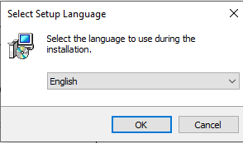
 | Click Next for installation to complete. Once it is installed. Close the application | 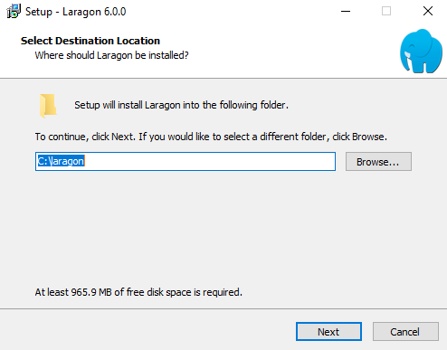
 | Confirm if Laragon or whichever server (XAMPP or WAMP) is successfully installed by checking in the taskbar or search panel. | 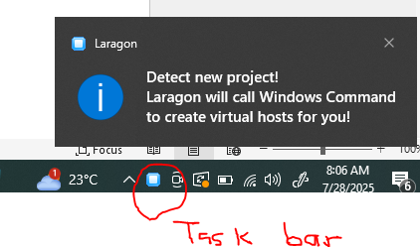
 | This level will require internet connection to download the phpMyAdmin and install along | 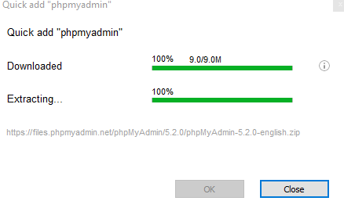
 | This will open this page:  Username: root  Password: leave blank  Click Login | 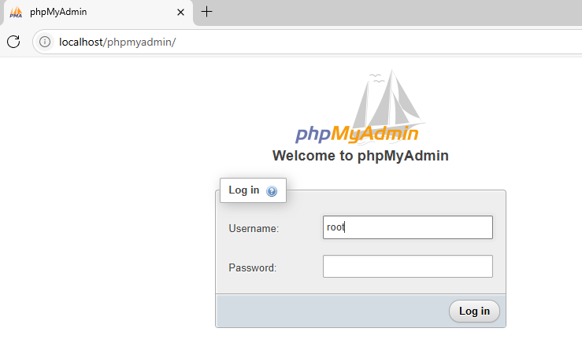
 | Download the project folders from https://drive.google.com/file/d/1V8ywMDUk6NCiKcup9CaSP76vElru-WjK/view?usp=drive_link and unzip to the laragon folder www or htdocs for XAMPP and give it your desired name example: Methadone | This PC > Local Disk (C:) > laragon > www > IORPMS  This PC > Local Disk (C:) > XAMPP > htdocs > IORPMS
 | This will open the following screen. Click on Databases and enter  methadone and choose utf8mb4_general_ci collation | 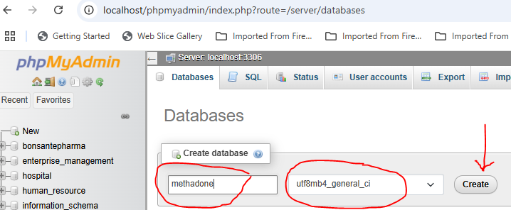
 | Import database from the folder C:/laragon/www/IORPMS/backup/database/iorpms.sql | 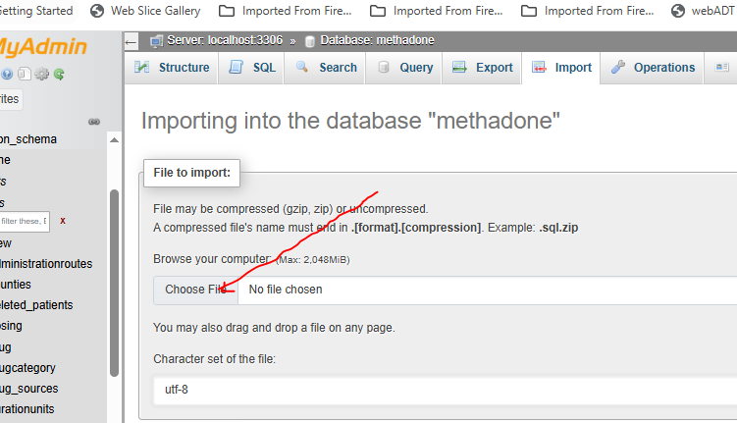
 | Type the following in url and press enter key http://localhost/iorpms/  This will open the following screen  Username: admin  Password: 123456 and login | 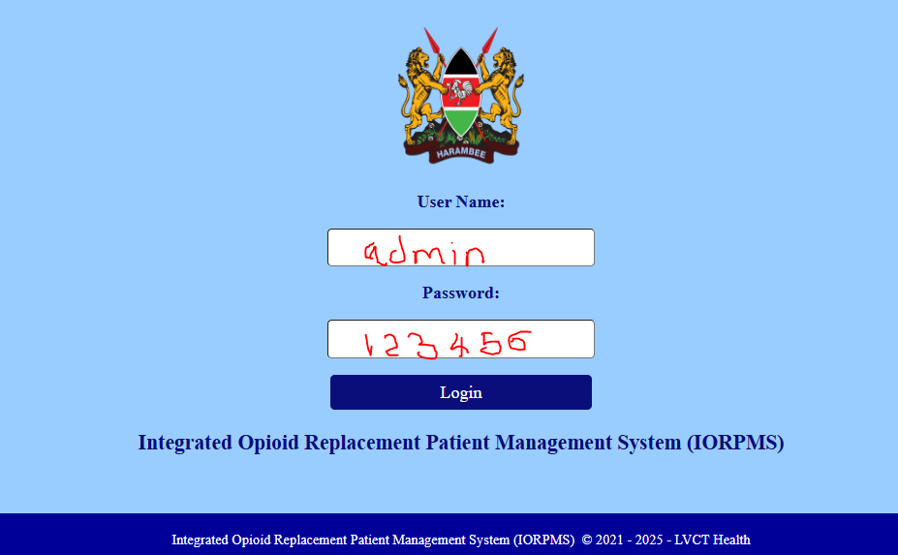
 | This will be the landing page | 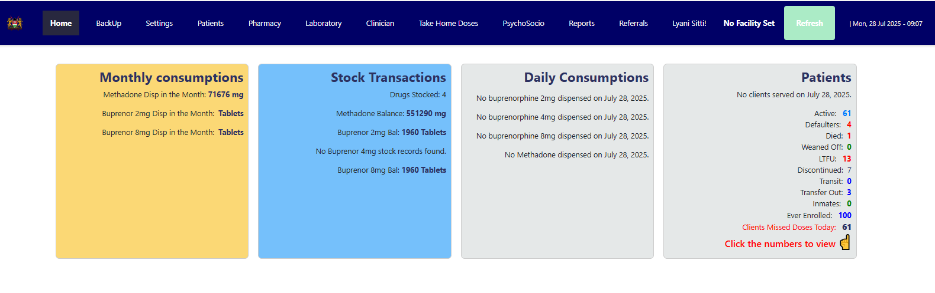
 | Go to settings > settings>initial facility settings | 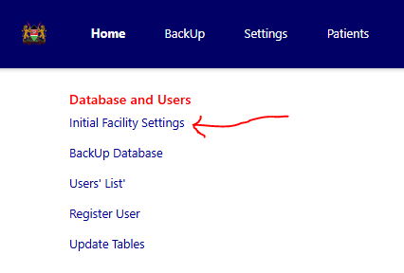
 | Select the facility and other settings will auto-populate and then fill in the facility in charge, phone and email  Save and submit | 